# AMPC Safety Spotlight event agenda

|  |  |  |
| --- | --- | --- |
| **Time** | **Topic** | **Speakers** |
| 7.30am | Registrations open |  |
| 8.00am | Welcome, opening address, AMPC updates, introduce providers | David Carew and Amanda Carter, AMPC |
| 8.30am | Provider pitches | Alister Joyce, Highgate  Mark Heaysman, Longitude6  Reece Daniels, Talisman |
| 9.00am | Mock trial – Understanding psychosocial legislation | Andrew Douglas, Kim McLagan and Nina Hoang, FCW Lawyers |
| 12.30pm | Lunch |  |
| 1.15pm | Leading psychological safety culture | Steve Sharp, Culture 360 |
| 2.00pm | Time management | Cyril Peupion, Work Smarter: Live Better |
| 3.30pm | Afternoon tea |  |
| 4.00pm | Safety Award pitches |  |
| 6.00pm | Pre-dinner drinks  **Horizon room at Crown Towers** |  |
| 6.30pm | Dinner  **Horizon room at Crown Towers** |  |
| 7.15pm | Keynote speaker | Kate Munari |
| 8.30pm | Safety Award announcements | Amanda Carter, AMPC |
| 10.30pm | Dinner ends |  |

|  |  |  |
| --- | --- | --- |
| **Time** | **Topic** | **Speaker** |
| 8.00am | Summary of first day | David Carew and Amanda Carter, AMPC |
| 8.15am | Provider pitches | Stacey McKenna, Meat Business Women  Jemma Harper, AMIC |
| 8.45am | Psychosocial safety – impact, issues, and innovation | Simon Booth, AEGIS Risk Management Services |
| 9.15am | AMPC wellbeing research project | Carli Phillips, Corporate Wellbeing Hub |
| 9.45am | Morning tea and provider Demonstrations | Corporate Wellbeing Hub  Risk Injury Management Services  Work Healthy Australia  Think Digital  Mimeo Industrial  Meat Business Women  AMIC  Highgate  Longitude6  Talisman |
| 11.00am | Palm employee mental health and wellbeing research project with JBS | Carli Phillips, Corporate Wellbeing Hub and  JBS |
| 11.45am | Safety in advanced manufacturing | Stuart Shaw, AMPC |
| 12.15pm | Case study: Shadow robotics | Barbara Webster and Connor Eatwell, Mimeo Industrial and JBS |
| 12.35pm | Working lunch |  |
| 1.00pm | Exoskeleton project update | Chris Fitzgerald, Risk Injury Management Services |
| 1.20pm | Technology in injury management | Shane Weaver, Work Healthy Australia |
| 1.50pm | Integrating technology and safety | Kat Bidstrup and Tim Gentle,Think Digital |
| 2.20pm | Wrap-up |  |
| 2.30pm | Spotlight closes |  |

# Speaker and session blurbs

## Carli Phillips – Corporate Wellbeing Hub

Carli is a Wellbeing Lead Researcher, Keynote Speaker and CEO of Corporate Wellbeing Hub. She was the wellbeing lead at Johnson & Johnson and was a recipient of the “Best Health & Wellbeing Program 2020.” With a degree in health science and a master’s in business, Carli’s research uncovered key success criteria needed to build successful wellbeing programs. She is a nutritionist, mental health first aider and expert wellbeing facilitator. With red meat industry experience, she has also developed unique wellbeing resources.

Carli will show findings unique to Pacific Islander employees in the red meat industry.  See the top risks and protective factors that differ from the local workforce with tips and training guides for your HR and training teams. She will present wellbeing metrics from over 1000 employees in the red meat industry.  Attendees will see physical and mental health risks as well as workplace wants and needs.  Industry-specific resources will be showcased, across financial wellbeing, mental health strategic plans and training resources. 

## A close-up of a person smiling AI-generated content may be incorrect.Chris Fitzgerald – Risk Injury Management Services

Chris is a Certified Professional Ergonomist whose career has focused on improving workplaces to enhance process efficiency and reduce effort and risks. He has been involved in red meat processing for many years and has been influential in improvements now regarded as standard industry practice. Chris’s original background was in Prosthetics and Orthotics, and he is still involved in this field, delivering ongoing aid projects throughout Southeast Asia.

Recently, Chris used this expertise within an AMPC project to undertake a global search to procure exoskeletons most likely to suit the meat processing environment. Today, Chris will provide you with an overview of the rapidly changing world of exoskeletons and the opportunities and limitations of applying these devices to meat processing.

## Andrew Douglas, Kim McLagan and Nina Hoang - FCW Lawyers

The meat industry has many stories of safety prosecutions that were easy to prevent. It now finds itself as the target for safety regulators in all states because of the mixture of high-risk work, many employees where English is a second language and the psychological hazards common in processing plants. But to many of our leaders, the risks seem invisible. Often our operational teams are desensitised because no one has ever been hurt, and the high risks seem manageable.

Our friends at FCW lawyers, who work nationally across the meat industry, have developed a mock prosecution of these issues. The facts are drawn from over 50 meat industry-related serious injuries or deaths they have defended. The Mock Court allows you to see inside a Court when it goes wrong, in circumstances that are common at your worksite. The Mock Court is like a real court but is more relaxed and fun, and there is a deliberate focus on explaining how to manage the risks not just what happens when you get it wrong.

The Mock Court will include people you know as witnesses for the defence and the prosecution. And you can be their judge.

## A person wearing a hat AI-generated content may be incorrect.Kat Bidstrup and Tim Gentle – Think Digital

What would you do if you won a bus? Think Digital started with Tim Gentle’s winning answer to this Facebook competition question. With a 14-metre classroom on wheels delivering digital education across regional Australia, and South Australia’s Emerging Entrepreneur Kat Bidstrup soon on board, the business has evolved to be one of Australia's leading technology companies.

Drawing on their farming backgrounds, Tim and Kat focus on solving complex agricultural challenges through immersive technology. Their groundbreaking products CattleVR and RemoteVet.ai tackle training barriers and global biosecurity issues with practical, real-world applications. Both natural storytellers, Tim and Kat are engaging presenters, often drawing on real-world experiences and using live demonstrations of technology to engage and inspire participants. Working alongside research corporations, government agencies, and global educators, Tim and Kat remain committed to their shared vision: developing technology with purpose and leaving the planet better than they found it.

## Kate Munari – Keynote Speaker

Kate is Australia’s only female Navy helicopter pilot to have flown in Afghanistan, boasting a remarkable 17-year military career as an aircraft captain and formation commander in the Royal Australian Navy. Her journey took her from life-or-death encounters under enemy fire to prolonged stints aboard Navy ships, where she navigated high-pressure environments with unwavering precision and resilience. During her posting with the Commando Helicopter Force—including time in the UK and Afghanistan—she frequently made quick decisions under tough military circumstances. Notably, when her Sea King was targeted mid-air in a warzone, her split-second decisions safeguarded the lives of 18 personnel—a testament to her deep expertise and composure honed under extreme conditions.

In her keynotes, Kate draws on over two decades of military experience to share powerful lessons in resilience, mindset, and purposeful goal setting. She offers a fresh perspective on overcoming adversity by emphasizing leadership and safety—balancing the imperatives of ensuring team safety with achieving critical mission outcomes. Kate’s compelling storytelling not only inspires audiences to meet challenges head-on but also empowers them to transform obstacles into opportunities for success in both their professional and personal lives. Come and hear a snapshot of Kate's story on the night.

## A person standing in front of a blue wall AI-generated content may be incorrect. Barbara Webster and Connor Eatwell - Mimeo Industrial

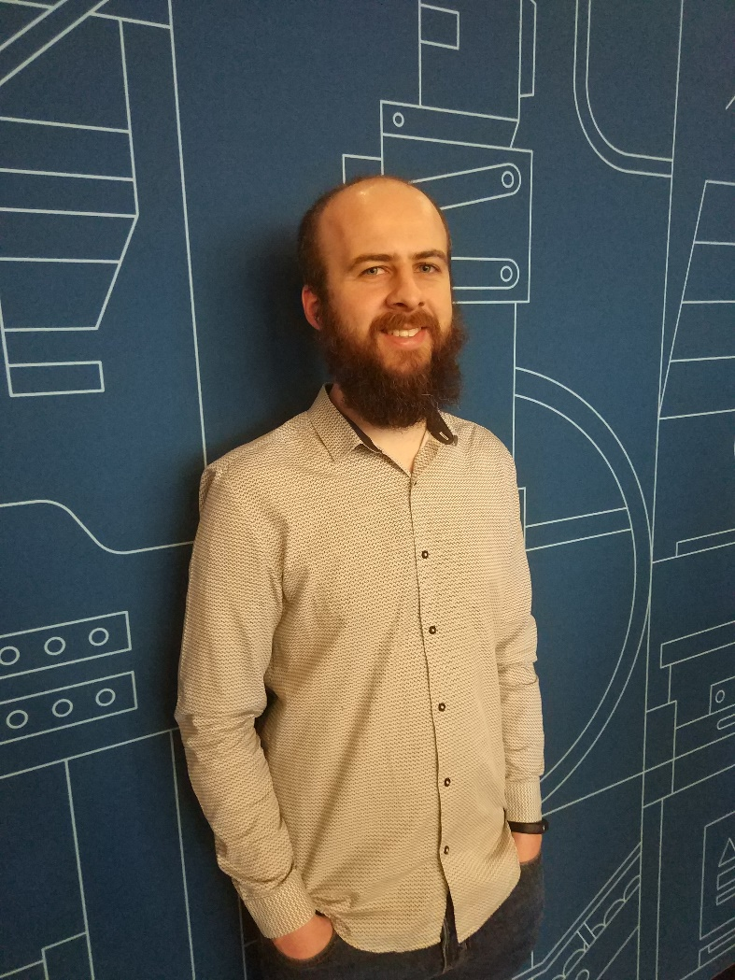Mimeo Industrial is developing shadow robot applications for the meat processing industry.  Our robot does the physical and repetitive work, while an operator controls it remotely from the comfort of an office with some in-room support. The system integrates machine vision, remote connectivity and robotics through software. Shadow robots offer the industry a new way of working. Barbara Webster, CEO, is part of the founding team at Mimeo.  Mimeo was established in 2021, and the team comes from a background in automation and robotics for various industries including meat processing. Barbara’s background is in new product development and technology commercialisation.  She’s joined at the event by Connor Eatwell, Mimeo’s Mechatronics Engineer.

Mimeo has partnered with AMPC and JBS over several years to commercialise our shadow robot applications.  We’re currently integrating the robots into the routine task of picking and packing in the boning room. So, we’d like to share our experience, learnings and the range of benefits that can come from combining robots doing the physical and repetitive work, with the skills of an operator.  Points of focus will include operational considerations having staff working alongside industrial robots (thanks to a safety skin), training, job skill changes and the opportunity to remove people from hazards in other shadow robot applications.

## Shane Weaver – Work Healthy Australia

Work Healthy Australia specialises in workplace injury prevention and management, supporting large organisations where employees perform manual handling or repetitive tasks. With an early intervention, biopsychosocial approach, Work Healthy Australia promotes faster recovery and supports sustainable return-to-work outcomes, especially in high-risk roles like those in the meat industry.

Shane Weaver heads up the Sales, Marketing and Client Account teams. He has a passion for collaboration, problem-solving and finding solutions to increase our clients’ productivity, creating an early intervention culture, and improving worker health and wellbeing. Shane enjoys building relationships and thrives on sharing his insights with new industries and organisations. His presentation will focus on the key barriers currently impeding recovery for injured workers within the Australian meat industry and will explore solutions to address these barriers.

## A person in a suit and tie AI-generated content may be incorrect.Simon Booth – AEGIS Risk Management Services

Simon Booth is the Director of Aegis Risk Management Services. Simon is a former psychologist who now specialises in People Risk.

Simon helps companies understand and manage the risk posed by the people in the organisation and works with them to mitigate the impact this has on their workers’ compensation premiums.

Simon will discuss the personal and commercial impact of psychological safety. He will outline the issues facing businesses in this space and provide insight into how employers can address the complications associated with psychological safety.

## Steve Sharp – Culture 360

Steve Sharp is a well-known leadership expert, in organisational culture and psychological safety diagnostics. Steve supports organisations in food processing, construction, manufacturing, financial services and government primarily focused on creating workplace environments that become competitive advantages through higher engagement and retention of employees and improved commercial performance over time. This work spans psychological safety culture diagnostics and analytics, leadership and team development programs, and executive-level culture development programs.

Steve will be delivering an entertaining session on why leaders today must understand what psychological safety is and how to curate their workplace environment so people can turn up, be themselves and want to contribute to their team and performance.

As Steve says, ‘discretionary effort is the holy grail’, his session will give you the practical leadership habits that generate discretionary effort from teams over time.

## A person in a suit and tie AI-generated content may be incorrect.Stuart Shaw – AMPC

Stuart is the Program Manager for Advanced Manufacturing at the Australian Meat Processor Corporation. With more than 34 years of experience in multiple industries driving innovative technologies to commercial success, his career has focused on engineering, innovation and business development of automated solutions including machinery, robotic systems and automated production for manufacturing industries.

Stuart will present on the impact of current AMPC Advanced Manufacturing Program initiatives have to address work, health, and safety industry needs.